A Learning Model on Customer Churn Forecasting for Telecom Providers

Sunkara Venkata Manikanta Kumar, Syed Asmath, Tangula Ramakrishna, Tummala Shalini
Department of Computer Science, Raghu Engineering College – Visakhapatnam, Andhra Pradesh, India

Email: 21981a05d9@raghuenggcollege.in, 21981a05f9@raghuenggcollege.in, 21981a05g5@raghuenggcollege.in, 21981a05h1@raghuenggcollege.in

ABSTRACT

The rapid expansion of technology infrastructure has changed business. With the rise of digitalization, subscription-based services have become increasingly popular and large options for services and products, resulting in customer losses becoming a serious problem and threat. Companies are developing technologies to predict potential customer wear as they directly impact profitability. It is important to determine the cause of this immigration to avoid customers. Preparing an immigration model that helps companies identify customers acting for bathtubs is a major contribution to our work. Before using classification techniques, customer data performs many data preprocessing levels. Support vector classifiers, logistic regression, and other classification techniques were used to examine customer wear.

INTRODUCTION

Getting a competitive edge is crucial in today's fiercely competitive corporate environment [1].
Maximizing profits is the main goal for businesses to succeed in this climate. Retaining current customers is far less expensive than obtaining new ones or persuading current ones to buy new plans. As a result, businesses need to act to please their customers and entice them to continue their services. Customers may move to other providers if they are dissatisfied with a company's quality or service, which would be a loss for the business. This is known as "customer

churn," which designates the incident of a customer canceling their subscription with one business and joining another for a variety of reasons.

Customer service, competitive pricing, and customer issues are the main reasons for customer churn. Both voluntary and involuntary churn can occur. Involuntary churn is when a consumer leaves the business because he is unhappy with the company's practices, non-paid, or the caliber of a product or service. Voluntary churn is motivated by technology development, quality of service, other psychological variables, or voluntary deviations. This is caused by personal circumstances such as movement and financial changes.

There are two approaches to solving this issue: proactive and reactive. Businesses that use the reactive approach do nothing until a customer cancels their subscription. Businesses that use a proactive approach are able to better nurture connections with angry customers and provide incentives to them by anticipating customer attrition before it happens. Thanks to technological improvements, businesses may now anticipate churn, which lowers churn rates and boosts profitability [8].

Since data mining techniques are accurate and efficient, they are essential to this process. By extracting knowledge from data, these methods—which include statistics and machine learning algorithms—help businesses create prediction models, comprehend consumer behavior, and make more informed decisions. In machine learning, this procedure is regarded as a classification task [9].

The application of several dimensionality reduction strategies, including feature extraction and selection, this study's key subjects are machine learning methods for predicting client attrition. Rebalancing the dataset also entails putting class balancing strategies like Random Oversampling, Tomek Links, and SMOTE into practice. AUC curves and k-fold cross-validation are used to evaluate the models' performance. The final section presents the research findings and discusses important preparation topics, previous work on this topic, the recommended method, and its evaluation.

LITERATURE REVIEW

In the telecom industry, forecasting client attrition is a critical problem because of the intense rivalry. A range of machine learning techniques are used for this purpose. To address this challenge, Chimankpam and Kamil [1] estimated client churn using the Teldata dataset. Neural networks (with Adam optimization), SVM (with linear, RBF, polynomial, and sigmoid kernels), and MLP (with Adam, SGD, and LBFGS algorithms) were compared. Their findings showed that neural networks with Adam optimization performed better than other techniques. Proposing that telecom corporations may use this technology to estimate client turnover.

The importance of predictive accuracy and interpretability in customer churn prediction models was analyzed by Lawani [2]. The study compared various machine learning techniques, including decision trees, support vector machines (SVM), and ensemble methods, to evaluate their effectiveness in forecasting customer attrition. While deep learning models demonstrated higher accuracy, traditional models such as logistic regression and decision trees provided better comprehensibility. The research also addressed challenges related to imbalanced datasets and emphasized the role of feature engineering in enhancing model performance. The findings highlight the need for selecting models that balance accuracy with interpretability to support business decision-making in customer retention strategies.

The study by Benjamin [3] explores customer churn prediction in the B2B sector using machine learning techniques. Unlike B2C churn prediction, which relies heavily on individual customer behaviors, B2B churn prediction involves complex factors such as long-term contracts, relationship management, and enterprise-specific interactions. Their findings indicate that ensemble methods outperform traditional statistical models in predictive accuracy. Additionally, feature importance analysis revealed that contract length, frequency of support interactions, and payment behavior were strong predictors of churn. The study underscores the significance of integrating machine learning with domain expertise to enhance model interpretability and justifiability in B2B environments.

The importance of this data for Telco businesses was highlighted by Sjarif et al. [4] when they investigated customer churn prediction in the telecom sector. They proposed a churn prediction model based on the Pearson's correlation function and the K Nearest Neighbour (KNN) technique, which was tested using a 70:30 split of the training and testing datasets. The results showed that the KNN method performed better than the others, with an accuracy of 97.78% in testing and 80.45% in training.

A European pay-tv company's use of analytical CRM to minimize customer attrition was proven by Burez and Van den Poel [5]. They employed logistic regression, random forest, and Markov chains for constructing churn prediction models. In a field trial, the selected model was used to target high-churn probability consumers with three marketing actions: customer satisfaction surveys, special customer events, and free incentives. The churn prediction model may quadruple revenues, according to the data; customer satisfaction surveys produced the greatest findings, which is why this phenomenon is known as the "mere-measurement effect" in psychology research.

Considering the greater costs associated with obtaining new consumers, Hadden et al. [6] stressed the value of keeping current ones. They covered several churn control strategies and emphasized the importance of accurately identifying customers who are at risk of walking away. The study examined common technologies for creating a platform for managing customer churn and talked about their benefits, drawbacks, and potential future research areas.

Lemos and Tabak [7] used data from a sizable Brazilian bank to study customer attrition prediction in the banking industry. Their study tested several machine learning algorithms and examined customer behavior features to predict future turnover. It was discovered that random forests performed better than decision trees, logistic regression, elastic net, k-nearest neighbors, and support vector machines. The study emphasized the significance of borrowing behavior, product consumption, and customer connections in churn prediction. The capacity of the model to predict possible losses indicates a noteworthy economic impact, underscoring the significance of cross-selling and upselling tactics in maintaining client loyalty.

EXPLORATORY DATA ANALYSIS

Exploratory data analysis (EDA) is the process of analyzing data sets to identify their salient characteristics; it often makes use of visual aids. The primary goal of exploratory data analysis (EDA) is to comprehend what the data might reveal beyond formal modeling or hypothesis-testing tasks. It employs a range of methods and techniques to look for trends, correlations, anomalies, and other insights in the data.

Here’s an overview of some common techniques used in EDA:

1. Summary Statistics: Calculate descriptive statistics such as mean, median, mode, standard deviation, range, etc., for understanding the central tendency and the diffusion of data.

2. Data Visualization: Utilize plotting tools like as histograms, box plots, scatter plots, bar charts, etc. to create visual representations of the data. Finding patterns, trends, outliers, and linkages in the data is made easier with the use of visualization.

3. Distribution Analysis: Examine the distribution of individual variables to understand their shape, skewness, and spread. This can involve techniques like Kernel Density Estimation (KDE), Probability Density Functions (PDF), etc.

4. Correlation Analysis: Explore the relationships between variables by calculating correlation coefficients (e.g., Pearson correlation, Spearman rank correlation) and visualizing them using correlation matrices or heatmaps.

5. Outlier Detection: Identify and analyze outliers in the data, which may indicate errors, anomalies, or interesting observations. Techniques like box plots, z-score, or IQR (Interquartile Range) can be used for outlier detection.

6. Missing Values Treatment: Examine missing values in the dataset and decide on appropriate strategies for handling them, such as imputation, deletion, or modeling techniques that can handle missing data.

7. Feature Engineering: To boost the effectiveness of machine learning models or to extract more information from the data, add new features or modify current ones.

8. Dimensionality Reduction: Minimize the dataset's variable count while maintaining its key attributes. Dimensionality reduction is frequently achieved by techniques that include Principal Component Analysis (PCA) or t-distributed Stochastic Neighbor Embedding (t-SNE).

EDA is frequently the initial stage of data analysis and is very important for modelling or hypothesis testing tasks that follow. It facilitates the development of hypotheses for more research, improved comprehension of the data, and decision-making on data preprocessing for data scientists and analysts. The stages in the suggested model are represented in fig 1. The subsections that follow go into greater depth on each one of these stages.

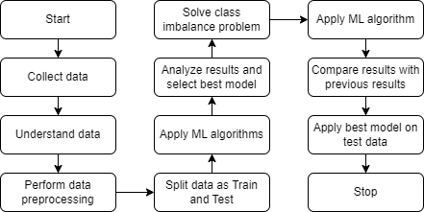
Fig. 1 Steps in the proposed model

- Understand dataset:
The dataset utilized in this study was sourced from the Kaggle website and comprises 7043 instances with 21 features. These include 20 independent features and one dependent feature, "Churn". Among the 7043 instances, 5174 have a churn value of "No" and 1869 have a churn value of "Yes". This indicates a clear class imbalance, with 73.5% of instances having a churn value of "No" and 26.5% having a churn value of "Yes". Figure 2 provides a visual representation of the dataset's description.

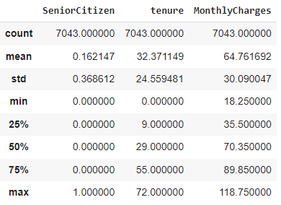
Fig. 2 Description of the dataset

- Data transformation / Feature engineering:
Among the features in the dataset, only 3 are numeric, while the remaining 18 are non-numeric and need to be encoded into a numerical format. The missing values in the numeric columns are populated with the mean of their relevant columns. For the non-numeric features, Label Encoder is applied to 6 features that have two unique values, assigning them values of 0 and 1. For the remaining categorical features, one-hot or dummy encoding is used. This encoding represents categorical data as vectors of zeros and ones. A separate dummy variable is created for each category, with a value of 1 indicating that the observation falls into that category and 0 otherwise.

- Data visualization:

Data visualization is a critical phase in the data science process. Once data is collected, processed, and modeled, it needs to be visualized to draw conclusions. One of the most significant achievements of data visualization is finding data patterns. When data is presented visually rather than in a table, it becomes much easier to identify trends. The plots in Fig. 3 show the distribution of data in a few categorical features.

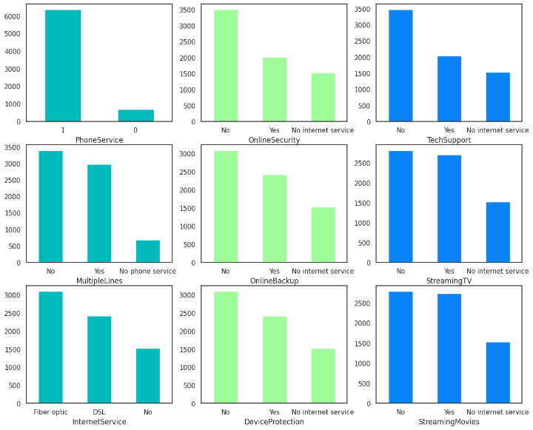
Fig. 3 Distribution of various Label Encoded Categorical Variables

- Feature elimination
Correlation is a statistical measure that shows how one feature changes or moves in relation to another feature. It gives us a general idea of how closely two features are related. If two variables are highly correlated, we can predict one variable from the other. Correlation helps us identify key features that other features depend on. The correlation heatmap in Fig. 4 illustrates the dependencies between features. It is evident that TotalCharges is highly correlated with tenure and MonthlyCharges. To check for multicollinearity in the features, the Variance Inflation Factor (VIF) has also been used, and features with close VIF values are dropped.

- Handling class imbalance
An imbalanced classification problem occurs when there is a bias or skew in the distribution of examples among the classes. This poses a challenge because many machine learning algorithms were developed with the assumption that every class will have a comparable number of samples. Consequently, these designs often underestimate the outcomes, especially when it comes to the minority class. Many techniques, such as under- and oversampling and cost modification, have been used to handle imbalanced classifications. The distribution of samples between the two classes of the dependent feature in this study, Churn, is shown in Fig. 5 with a ratio of 73.5:26.5. In order to balance the two classes and address this imbalance, the Synthetic Minority Oversampling method (SMOTE) creates synthetic samples for the minority class, thereby balancing the two classes. Because of this, both classes have 5174 samples each, ensuring a balanced dataset for modeling.

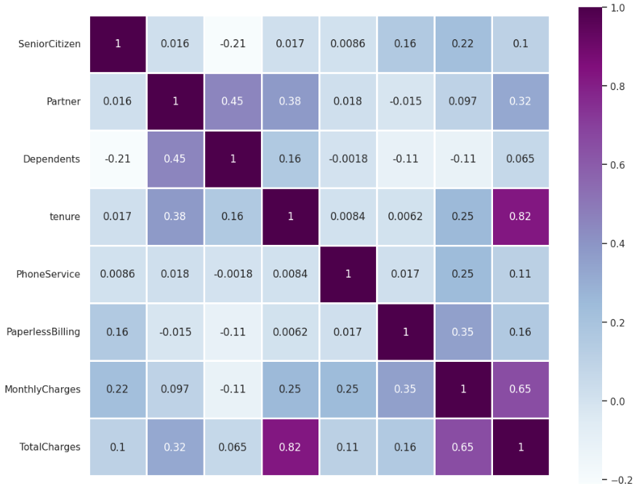
Fig. 4 Correlation heatmap
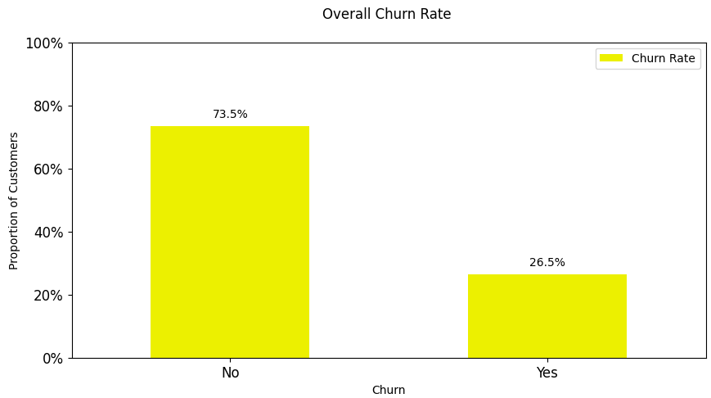
Fig. 5 Overall Churn rate

MACHINE LEARNING MODELS

6.3.1 Logistic Regression

In binary classification jobs, a statistical approach known as logistic regression is used. The variable that is dependent (output variable) is categorical and has two possible values, usually denoted by the codes 0 and 1. This kind of regression analysis works well for estimating the likelihood that an event will occur in light of one or more predictor factors.

6.3.2 Support Vector Machine

An SVC, or Support Vector Machine (SVM), is a supervised learning approach applied to tasks such as classification. Unlike logistic regression, which is primarily concerned with identifying the best-fitting line, or hyperplane in higher dimensions, support vector sampling (SVC) aims To find the hyperplane that effectively separates the data into different classes and maximizes the margin, which is the distance between the hyperplane and the nearest data points (known as support vectors).

6.3.3 Naïve Bayes algorithm

The "naïve" assumption of conditional independence between characteristics underlies the straightforward and efficient probabilistic classification procedure known as Naïve Bayes classification, which is based on Bayes' theorem. Even though they seem straightforward, Naïve Bayes classifiers frequently work effectively in real-world scenarios and are especially helpful with high-dimensional data.

6.3.4 Decision Tree

The decision tree classifier is a widely used machine learning technique for classification and regression problems. This non-parametric supervised learning technique learns a series of hierarchical decision rules from the feature variables are used to forecast the class label of the variable being targeted.

6.3.5 Random Forest
One popular ensemble learning technique for tasks involving regression and classification is called Random Forest. When compared to individual trees, this robust and adaptable method generates more accurate and consistent results by constructing several decision trees during training and combining their predictions.

RESULTS AND DISCUSSION

In Fig. 8.11, we have discussed the baseline classification algorithms, which include Logistic Regression, SVC, Random Forest, Gaussian Naïve Bayes and Decision Tree Classifier. For each algorithm, the table presents the following metrics: ROC AUC, Mean ROC AUC STD, Accuracy, and Mean Accuracy STD.

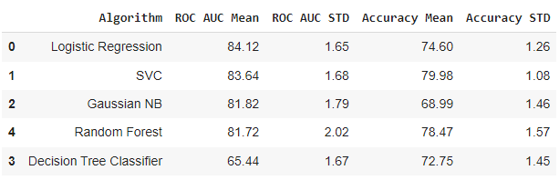

Fig. 8.11 Baseline Classification Algorithms - Using Accuracy and ROC AUC Mean Metrics

Fig. 8.12 displays a table comparing the baseline algorithms on the test data, urging the reader to visualize the results. The table includes statistics which includes F1 score, model accuracy, precision, recall, and F2 score for different algorithms (Logistic Regression, SVM, Naive Bayes, Random Forest, Decision Tree). Among these, Logistic Regression achieved the highest accuracy of 80.34%.

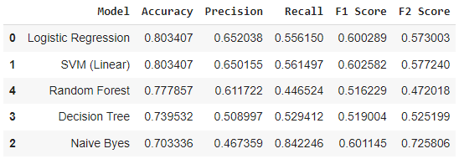

Fig. 8.12 Visualize the results and compare the baseline algorithms on Test data

A confusion matrix is shown in Fig. 8.13, which illustrates the faults that a Logistic Regression model makes. The matrix summarizes the model's predictions in relation to the test data's real labels by describing the efficacy of the model using a set of test data whose true values are known.

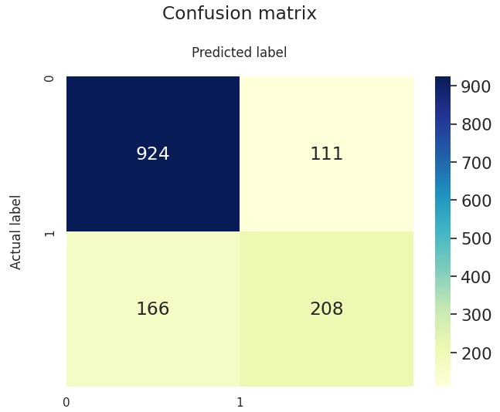
Fig. 8.13 Confusion Matrix for Logistic Regression

The fig 8.14 depicts the Receiver Operating Characteristic (ROC) curve, which indicates the difference between thresholds. It compares the true positive rate (TPR) to the false positive rate (FPR) at different thresholds. The area under the ROC curve (AUC) is calculated and given in the caption.

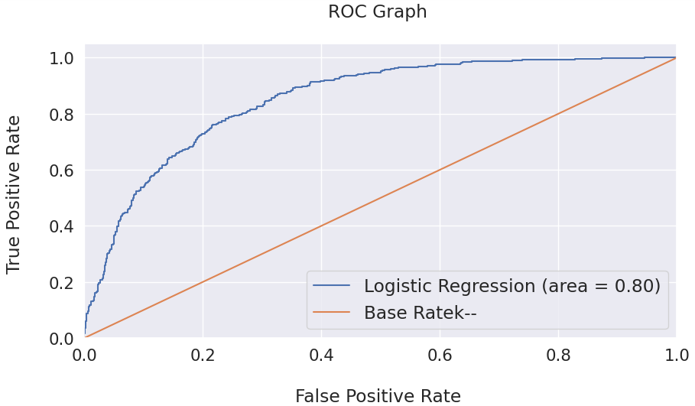
Fig. 8.14 ROC Graph for Logistic Regression

After utilizing the SMOTE oversampling technique, the accuracy and ROC AUC Mean metrics are used to illustrate the performance of the baseline classification algorithms in Fig. 8.15. With regard to the train dataset, the Random Forest and Decision Tree models exhibit 99% accuracy, as given in this picture.

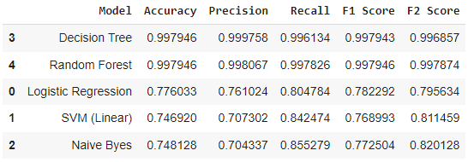

Fig. 8.15 Baseline Classification Algorithms - Using Accuracy and ROC AUC Mean Metrics after performing SMOTE oversampling technique.

Figure 8.16 visualizes the results and compares the baseline algorithms on the test dataset. In this figure, Random Forest achieves the highest accuracy of 80%, which is the key takeaway.

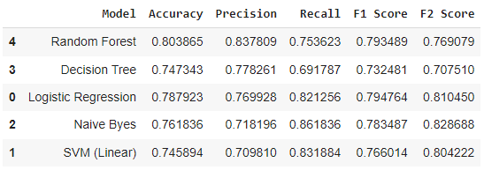
Fig. 8.16 Visualize the results and compare the baseline algorithms on Test data.

CONCLUSION

For modern subscription-based businesses, managing customer churn, and specifically predicting churn, is crucial. Hence, the aim of this study was to develop a system capable of predicting customer churn in business. Our findings indicate that machine learning can predict customer attrition with high accuracy. Through machine learning, we explored various aspects related to customer churn prediction, contributing to a better understanding of how machine learning can be applied in this context.

In this paper, we tested five classification algorithms on a customer dataset to predict customer churn. Our model pipeline includes several data preprocessing steps, such as visualizing data, removing features based on correlation and VIF, and addressing class imbalance. The set of records is split between tests and training information in an 80:20 ratio, and the data is normalized before applying machine learning algorithms. The classification algorithms used in the study are Support Vector Classifier, Logistic Regression, Gaussian Naïve Bayes, Decision Tree Classifier, Random Forest. The performance of these algorithms is evaluated using various metrics.

REFERENCES
- N. V. Chimankpam and D. Kamil, “Customer churn prediction for business intelligence using machine learning,” in 2021 3rd International Congress on Human-Computer Interaction, Optimization and Robotic Applications (HORA), June 2021, pp. 1–7.
- Lalwani, Praveen & Mishra, Manas & Chadha, Jasroop & Sethi, Pratyush, “Customer Churn Prediction System - A machine learning approach”, January 2022.
- Benjamin Ghaffari & Yasin Osman, “Customer churn prediction using machine learning A study in the B2B subscription-based service context” June 2021.
- N. N. A. Sjarif, M. R. M. Yusof, D. H. Wong1, S. Ya’akob1, R. Ibrahim1, and M. Z. Osman, “A customer churn prediction using pearson correlation function and k nearest neighbor algorithm for telecommunication industry,” Int. J. Advance Soft Compu. Appl, vol. 11, no. 2, 2019.
- J. Burez and D. Van den Poel, “CRM at a pay-tv company: Using analytical models to reduce customer attrition by targeted marketing for subscription services,” Expert Systems with Applications, vol. 32, no. 2, pp. 277–288, 2007
- J. Hadden, A. Tiwari, R. Roy, and D. Ruta, “Computer assisted customer churn management: State of-the-art and future trends,” Computers & Operations Research, vol. 34, no. 10, pp. 2902–2917, 2007.
- T. C. S. Renato Alexandre de Lima Lemos and B. M. Tabak, “Propension to customer churn in a financial institution: a machine learning approach,” Neural Computing and Applications, 2022.
- D. Soumi, P. Prabu, and P. Joy, “Effective ml techniques to predict customer churn,” in 2021 Third International Conference on Inventive Research in Computing Applications (ICIRCA), 2021, pp. 895–902.
- M. Debajyoti, M. Aarati, N. Anagha, and S. Shriya, “An approach to mitigate the risk of customer churn using machine learning algorithms,” in Machine Learning for Predictive Analysis, J. Amit, K. Mahdi, and G. Neeraj, Eds. Singapore: Springer Singapore, 2021, pp. 133–142.
- N. N. Vo, S. Liu, X. Li, and G. Xu, “Leveraging unstructured call log data for customer churn prediction,” Knowledge-Based Systems, vol. 212, p. 106586, 2021.
- S. Animesh, “Application of machine learning and statistics in banking customer churn prediction,” in 2021 8th International Conference on Smart Computing and Communications (ICSCC), July 2021, pp. 37–41.

